Perennial Bloom Calendar
Designing for Four Seasons of Flowers
Dreaming of a garden ﬁlled with nearly never-ending ﬂowers?
With a little planning, your garden can have blooms almost all yearlong. Unlike summer annuals that bloom consistently over manymonths, perennials generally have a window of time when theirﬂower ﬂushes appear. By following this guide, you can design aperennial garden that will provide four seasons of interest.
Visit a local gardening center in spring and you will ﬁnd a myriad ofperennial plants all in full ﬂower. If you were to purchase aselection of these and plant them at home, chances are you wouldhave lots of ﬂowers for a few weeks or so, but then when summerrolled around your yard would have lost a lot of its bloom. That’sbecause for the most part, the showiest, most eye-catching plantsin the nursery are for sale during their peak bloom time. If you shop a few times throughout the seasons, you’ll see different plants blooming at different times. With a little planning, you candesign a garden with four seasons of ﬂowers. This guide aims tohelp. We have selected a number of common perennial ﬂoweringplants and mapped out their general ﬂowering times.
when perennial ﬂowers will appear:
Seasonal issues: Every season is different. If, for instance, we have a very cold spring, this willprobably push back the bloom times of many early season ﬂowers. Alternatively, if we have a verywarm spring, many plants will bloom early. A hot, dry summer with drought conditions may alsocause a change in bloom times.
Age of Plant: More mature plants tend to put out more blooms over a longer period.
Culture: Following the recommendations for amount of sun, water, and fertilizer is very important tokeep perennials blooming their best. If a sun-loving plant is put in too much shade, it will not perform well. If a plant does not get the amount of water or nutrients it needs it also will not perform.
Extending Bloom Times: Sometimes plants will put out another ﬂush of ﬂowers if they are shearedback after the ﬁrst blooms fade. Plant tags will usually tell you if this is a good idea. Deadheadingspent ﬂowers can prolong blooming almost indeﬁnitely. Perennials also may need to be thinned ordivided every few years to keep them in top form.
Varietal Differences: Sometimes there are many species of the same plant that will have different qualities and bloom times. Check the tags or ask if you are unsure about when a particular plant issupposed to bloom.
Questions? We’re always happy to help. Stop by the Information desk or email us at
info@portlandnursery.com

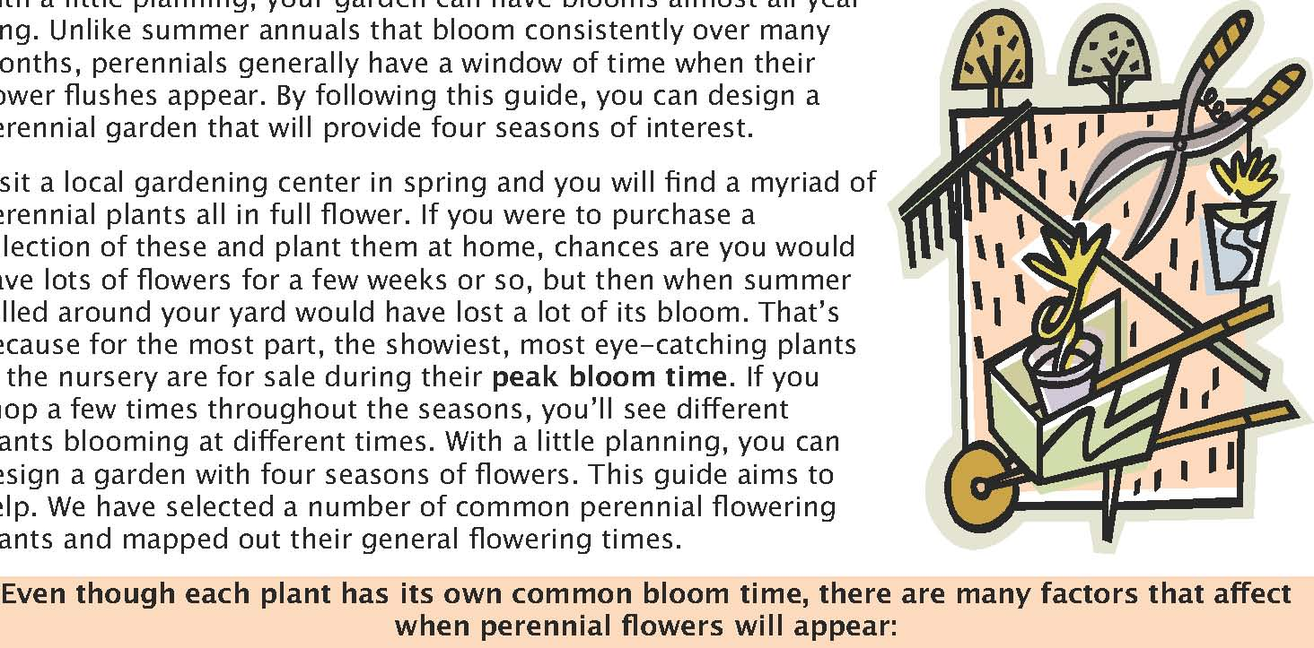
Bloom Times for Perennials
Plant Name | Jan. | Feb. | March | April | May | June | July | Aug. | Sept. | Oct. | Nov. | Dec.
Achillea (Yarrow)
Aconitum* (Monkshood)
Actea /Cimicifuga*(Bugbane)
Agastache (Anise hyssop)
Anemone* (Japanese)
Aquilegia (Columbine)
Arabis** (Rock cress)
Aster
Aubrieta
Aurinia** (Basket-of-Gold)
Bellis (English Daisy)
Brunnera*
Campanula(Bellﬂower)
Centaurea
Chrysanthemum
Coreopsis
Corydalis*
Crocosmia
Dahlia
Delphinium
Dianthus (Pinks)
Dicentra* (Bleeding Heart)
Digitalis* (Foxglove)
Echinacea (Coneﬂower)
Erigeron (Fleabane)
Eryngium (Sea Holly)
Erysimum**(Wallﬂower)
Fuchsia*
Gaillardia (Blanket Flower)
Gaura
Geranium (Cranesbill)
Geum
Helenium (Sneezeweed)

Plant Name | Jan. | Feb. | March | April | May | June | July | Aug. | Sept. | Oct. | Nov. | Dec.
Helianthemum**(Sun Rose)
Helleborus*, **
Hemerocallis (Daylily)
Iberis** (Candytuft)
Leucanthemum (Daisy)
Lithodora**
Lupinus (Lupine)
Monarda (Bee Balm)
Myosotis*(Forget-Me-Not)
Nepeta (Catmint)
Paeonia (Peony)
Papaver (Poppy)
Penstemon
Perovskia (Russian Sage)
Phlox (short)
Phlox (tall)
Phygelius (CapeFuchsia)
Primula* (Primrose)
Rudbeckia (Black-Eyed Susan)
Salvia
Saxifraga*, **
Scabiosa (Pincushion Flower)
Thalictrum* (MeadowRue)
Tricyrtis* (Toad Lily)
Veronica (short)
Veronica (tall)
Viola*

Darkest-colored cells indicate main bloom time. Lighter-colored cells indicate start, ﬁnish, or sporadic bloom times.
*Indicates shade tolerance **Indicates evergreen plant

Perennials for Shade
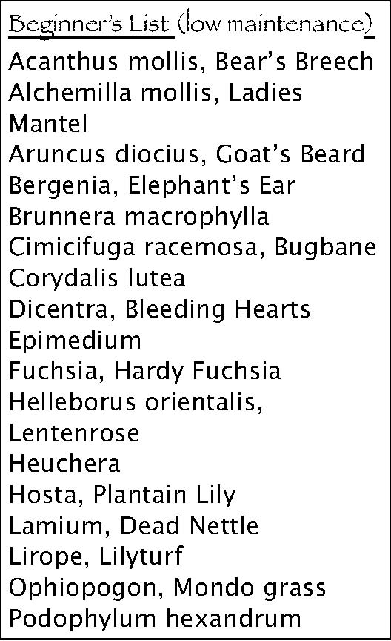
Beginner’s List (low maintenance)
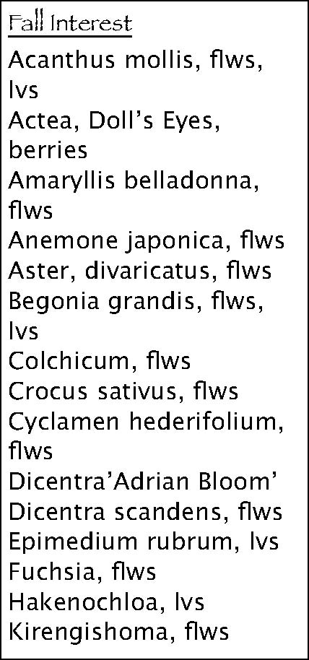
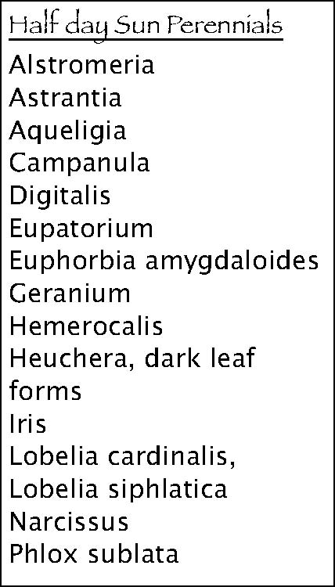Fall Interest
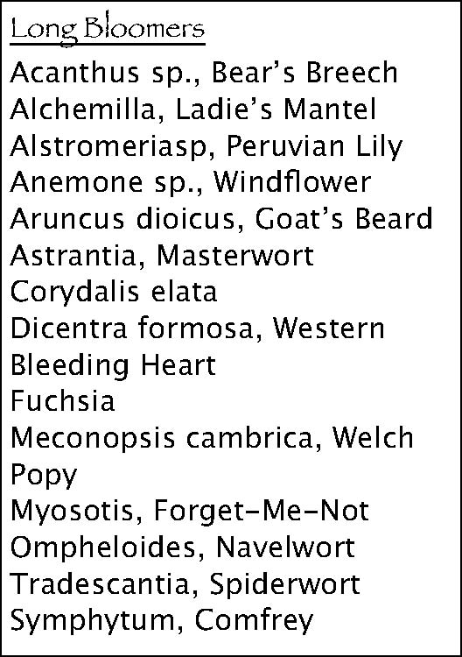
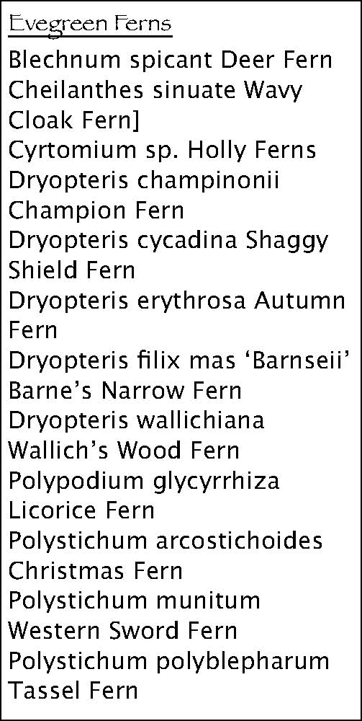Long Bloomers
Acanthus mollis, Bear’s BreechAcanthus mollis, ﬂws, Acanthus sp., Bear’s BreechAlchemilla mollis, Ladies lvs Alchemilla, Ladie’s MantelMantel Actea, Doll’s Eyes,Alstromeriasp, Peruvian LilyAruncus diocius, Goat’s Beardberries Anemone sp., WindﬂowerBergenia, Elephant’s EarAmaryllis belladonna,Aruncus dioicus, Goat’s BeardBrunnera macrophyllaﬂws Astrantia, MasterwortCimicifuga racemosa, BugbaneAnemone japonica, ﬂwsCorydalis elataCorydalis luteaAster, divaricatus, ﬂwsDicentra formosa, WesternDicentra, Bleeding HeartsBegonia grandis, ﬂws, Bleeding HeartEpimediumlvs Fuchsia Fuchsia, Hardy FuchsiaColchicum, ﬂwsMeconopsis cambrica, WelchHelleborus orientalis,Crocus sativus, ﬂwsPopyLentenrose Cyclamen hederifolium,Myosotis, Forget-Me-NotHeuchera ﬂws Ompheloides, NavelwortHosta, Plantain LilyDicentra’Adrian Bloom’ Tradescantia, SpiderwortLamium, Dead NettleDicentra scandens, ﬂwsSymphytum, Comfrey Lirope, LilyturfEpimedium rubrum, lvsOphiopogon, Mondo grassFuchsia, ﬂws
Evegreen Ferns
Podophylum hexandrum Hakenochloa, lvs
Kirengishoma, ﬂws Blechnum spicant Deer FernCheilanthes sinuate Wavy Cloak Fern]
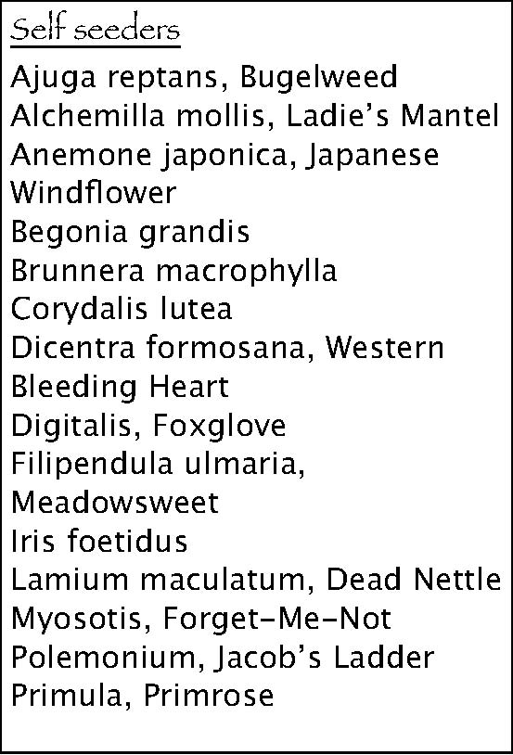Half day Sun Perennials Cyrtomium sp. Holly FernsAlstromeria Dryopteris champinoniiAstrantia Champion FernAqueligiaDryopteris cycadina Shaggy CampanulaShield Fern DigitalisDryopteris erythrosa Autumn
EupatoriumFern Euphorbia amygdaloidesDryopteris ﬁlix mas ‘Barnseii’
Barne’s Narrow Fern
Geranium Hemerocalis Dryopteris wallichianaHeuchera, dark leafWallich’s Wood Fern forms Polypodium glycyrrhizaLicorice Fern
Iris Lobelia cardinalis, Polystichum arcostichoides
Lobelia siphlaticaChristmas Fern Narcissus Polystichum munitum
Western Sword Fern
Phlox sublata Polystichum polyblepharum
Tassel Fern

Perennials for sun
Beginner’s List (low maintenance)
Amsonia Artemesia lactiﬂora ‘Guizhou’ Artemesia ‘Silver Mound’ Aubretia, Rock CressAster ’Purple Dome’Astrantia, MasterwortCampanula ‘Birch’s Hybrid’, Bellﬂower Campanula persicifolia, BellﬂowerCoreopsis verticillata, TickseedEuphorbia ch. ‘Humpty Dumpty’Gaillardia, Blanket FlowerHibiscus moscheutos Hemerocalis repeat bloomers,Daylily
Iberis, Candytuft Leucanthemum, Shasta Daisy Nepeta x faassenii, Catmint Pervoskia, Russian Sage Rudbeckia fulgida, R. nitida- Brown Eye
Perenials for Rock Walls (spillers)
- tolerates drought whenestablished *Aurinia saxatilis, Basket of GoldAubrieta Campanula carpatica, C. gargantica*Cerastium tomentosum, Snow in summer *Ceratostigma plumbaginoides,Plumbbago*Chiastophyllum oppostitfolium*Delospermum, Ice plantDiascia, Twinspur*Erigeron karvinskianus, Fleabane*Euphorbia rigida*Helianthemum, Sunrose
- Iberis sempervirens, Candytuft*Lithodora diffusea *Origanum ‘Kent Beauty’Phlox subulata, Creeping Phlox*Sedum *Sempervivum, Hens and Chicks

Fragrant Perennials
Aquilegia ‘ChocolateSoldiers’ Agastache sp (foliage)Berlandiera lyrataCosmos atrosanguineusDianthus sp.Echinacea ‘Fragrant Angel’Gladiolus callianthus Hemerocalis ﬂava,‘Tardida’? HesperisLily, Oriental & TrumpetNarcissus ‘Phesant’s Eye’Oenothera fragrans
Fall Bloomers
Anemone japonica,Windﬂower Achellia, YarrowAster sp.Boltonia, False StarwortCrocosmia, MontbretiaDendranthema, MumEupatorium purpureum,Joe Pye WeefHelenium sp.,Sneezeweed Helianthus sp, Perennial Sunﬂowers HeliopsisKniphoﬁa Lavatera, Tree MallowLeucanthemum, ShastadaisyPervoskia, Russian SageRudbeckia sp., Black eye Susan Salvia sp.SchizostylisSedum sp
Long Bloomers
Achillea Anthemis Campanula port.Centranthus ruber ChiastophyllumCoreopsisDianthus deltoids ErigeronErodium Gaillardia Gaura Geranium endressii,
G. sanguineumGypsophilapaniculataHelenium autumnale Helianthemum Iberis Lavetera Linaria purpureaOenothera sp.Phlomis fruticosa PhygeliusRudbeckia fulgidaSalvia Scabiosa Stachys
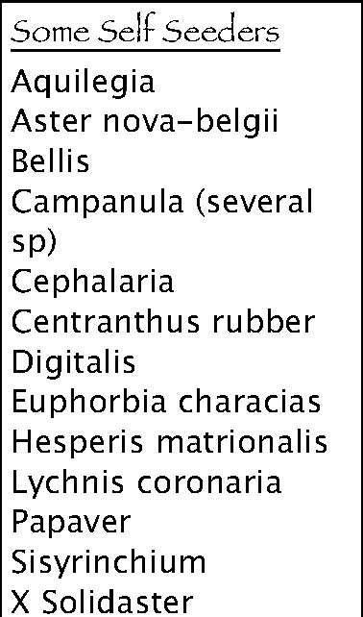
Some Self Seeders
AquilegiaAster nova-belgiiBellis Campanula (several sp)CephalariaCentranthus rubber DigitalisEuphorbia characiasHesperis matrionalisLychnis coronariaPapaverSisyrinchiumX Solidaster

Keeping tender perennials in the northwest

A tender perennial is deﬁned as a perennial, a plant that can live for many years, that is not winter hardy (will die in winter in one’s parFcular climate). SomeFmes these plants are called annuals for the sake of simplicity, but they are not true annuals, which cannot be live more than one year. This includes pelargoniums (so-‐called annual geraniums), many tropical ferns, tuberous begonias, some impaFens, fuchsias, tender sages, and others. Some even broaden this category to include tender shrubs such as hibiscus or citrus, but they should not properly be called perennials. For simplicity, here we will emphasize the most popular types of plants.
The basic concept of overwintering tender perennials is to manipulate the environment of the plant just enough so that it can behave like a perennial instead of an annual. The most important point within this is minimum temperature exposure. The gardener should start monitoring their plants in late Spetember to mid-‐October, watching for night temperatures that are coming close to freezing. Take those steps to protect your plant before the risk of a real freeze. The Portland area is usually considered to be USDA hardiness zone 8, which is a reference to how cold it gets here. For those perennials that are almost hardy here (USDA zone 9), someFmes a cold frame is enough, or a minimally heated enclosed environment. Some pelargoniums , fuchsias, and many assorted zone 9 plants can be kept in a semiprotected spot most of the winter in a container, but be ready to move them to a frost-‐free environment in case of a severe winter storm. Such a move should be temporary, just so the plants are not subject to very low temperatures. Pelargoniums, for example, can handle frost but not heavy freezes the way the (hardy) geraniums can.
Some might wonder why you should not just move the plant in to the house for the winter, growing it like any other houseplant, and this o8en happens. The end results are mixed, depending on the condiFons the plants receive and the types of plants used this way. Keep in mind that if you keep a sun-‐loving plant at room temperature all winter in a relaFvely dark living room, it will probably live and try to grow, but the growth will be very weak and ﬂoppy, resulFng in an unsaFsfactory appearance. Also, plants under such stresses can have exaggerated weakness to over-‐or under-‐watering.
A cool but frost free greenhouse is probably ideal for most of the plants that fall in this category. That said, most of us don’t have a greenhouse, so… Here are a few Fps on individual plant types and ways to keep them over the winter. Other areas for overwintering tender plants include garages, basements, and covered or enclosed porches.
Pelargoniums: If you choose to overwinter Pelargoniums inside, here are some Fps. Zonal and other such geraniums can be kept in a normal brightly lit indoor locaFon. They would prefer it cool, but don’t need it. What they absolutely need is to dry fully between waterings. Some even go so far as to water them no more than 2-‐3 Fmes all winter, though the goal here is not to speak in absolutes. Some people leave them outside in a covered (no rain) locaFon for the winter, and only move them in during severe freezes. This can be successful as well, as long as the plant is not too wet and you do catch it before the freezes.
As an alternaFve, the gardener can cut back their pelargoniums hard, and store them in the basement or garage, sFll keeping the soil mostly dry. Scented geraniums tend to make fairly good houseplants.
Fuchsias: Fuchsias are challenging to overwinter without agreenhouse environment. Note that asun room or enclosed porch can work preHy well, but anormal living room style of locaFon usually leads to a very sparse, unaHracFve plant that may not be worth your while. If you have a greenhouse or similar environment, then simply keep them cool but not freezing, moderately (not fully) dry between waterings, and pinch any excessive growth. Some ferFlizer in spring will perk them up nicely.
Ferns and Asparagus ferns: Most tender ferns make ﬁne indoor bright light houseplants. They should be kept moist but not soggy, and don’t be too surprised if they do some rapid shedding of leaves shortly a8er being moved. They will generally survive this and re-‐grow well given Fme. Asparagus ferns (not edible asparagus) can also make good houseplants, but can handle things a liHle cooler than some ferns, and prefer it somewhat brighter as well.
Alternately, you can let tender fuchsia go mostly dormant unFl they loose their leaves, then cut them back to the basic woody structure and store the pots in a cool, frost free area, such as a basement. Water sparingly.
Tuberous Begonias: Allow plants to naturally turn yellow in autumn weather, then cut oﬀ all the above ground growth. Dig up the tuber, dry it, and store it dry in a cool but frost free place, such as a basement. In late April or so, replant the tubers in fresh soil and regrow for a new season.
For further reading, there is a great arFcle on this subject on the website belonging to Fine Gardening Magazine. It can be found at hHp://www.ﬁnegardening.com/how-‐to/arFcles/overwinteringtender-‐plants.aspx?nterms=74880.
Alternately, go to Fine Gardening’s website, click to How-‐To tab, then look for the arFcle under the overwintering secFon.

